The antenna complex consists of
A. Accessory pigment
B. Chlorophyll-b
C. Carotenoids
D. All of these
ANSWER: D
Reaction centre, which contains and
A. only chlorophyll-a
B. associated proteins.
C. Both A and B
D. None of these
ANSWER: C
The chlorophyll-a in the reaction centre of PS-I can absorb a maximum _________ wavelength of light
A. 700nm
B. 680nm
C. 350nm
D. 900nm
ANSWER: A
The chlorophyll-a in the reaction centre of PS-II can absorb a maximum _________ wavelength
A. 700nm
B. 680nm
C. 350nm
D. 900nm
ANSWER: B
The photosystems are named for the order in which:
A. They occur in the thylakoid membrane
B. They were discovered
C. They were found in the chloroplast
D. They were function
ANSWER: B
The complete breakdown of glucose molecule takes place in which of the following?
A. Alcoholic fermentation
B. Lactic acid fermentation
C. Aerobic respiration
D. None of these
ANSWER: C

Each Krebs’s cycle forms how many molecules of NADH?
A. 3
B. 2
C. 4
D. 1
ANSWER: A
Which one is not an energy-releasing process?
A. Glycolysis
B. Photosynthesis
C. Respiration
D. Krebs Cycle
ANSWER: B
$C_{6}H_{12}O_{6}+6O_{2} →6CO_{2}+6H_{2}O+Energy$Represent:
A. Photosynthesis
B. Respiration
C. Anaerobic respiration
D. Aerobic respiration
ANSWER: D
Which of the following is a compensation point:
A. Leaves respire and utilize O2 and release CO2.
B. Photosynthesis and respiration occur at same rate. So there is not net exchange of gases between atmosphere and plants.
C. Rate of photosynthesis increases, so do the O2 production, with a net release of oxygen coupled with the uptake of CO2.
D. Rate of respiration becomes more than rate of photosynthesis.
ANSWER: B
When a _________is used as an energy source, it breaks down to glycerol and fatty acids
A. Carbs
B. Protein
C. Fat
D. Nucleic acid
ANSWER: C
The hydrolysis of proteins results in:
A. Carbs
B. Amino acids
C. Glycerol and fatty acids
D. Nucleic acid
ANSWER: B
Deamination:
A. the removal of fatty group
B. the removal of the amino group
C. the removal of glycerol
D. the removal nitrogenous base
ANSWER: B
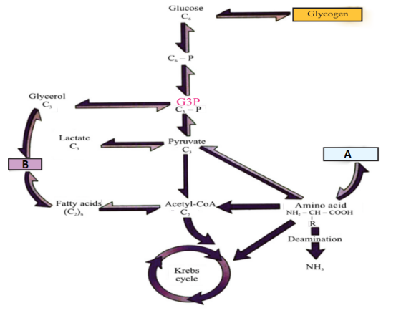
What does A represent in the given diagram
A. Carbs
B. Proteins
C. Fats
D. Nucleic acid
ANSWER: B

What does B represent in the given diagram
A. Carbs
B. Proteins
C. Fats
D. Nucleic acid
ANSWER: C

